Objectives

Familiar with Git commands like git init, git status, git add, git commit, git push, and git pull.

In this hands-on lab, you will learn how to
- Setup your machine with Git Configuration
- Integrate notepad++.exe to Git and make it a default editor
- Add a file to source code repository

Prerequisites

- Install Git Bash client in your machine

Notes*:
Please follow the below steps for creating a free account in GitHub.
Don’t use cognizant credentials to login to GitHub.

Estimated time to complete this lab: 30 minutes.

Step 1: Setup your machine with Git Configuration

To create a new repository, signup with GitLab and register your credentials
Login to GitLab and create a “GitDemo” project

- To check if Git client is installed properly: Open Git bash shell and execute

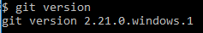

If output shows Git with its version information that indicates, that Git Client installs properly.

- To configure user level configuration of user ID and email ID execute

- To check if the configuration is properly set, execute the following command.

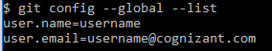
Step 2: Integrate notepad++.exe to Git and make it a default editor

- To check, if notepad++.exe execute from Git bash

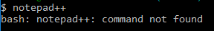
If Git bash could not able to recognize notepad++ command that implies notepad++.exe is note added to the environment path variable.

To add path of notepad++.exe to environment variable, go to control panel -> System -> Advanced System settings. Go to Advanced tab -> Environment variables -> Add path of notepad++.exe to the path user variable by clicking on “Edit”

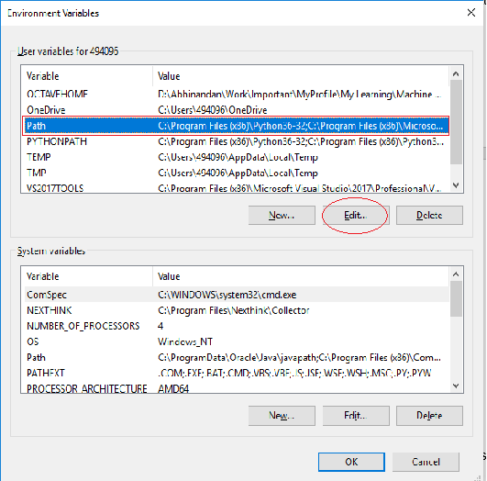

- Exit Git bash shell, open bash shell and execute

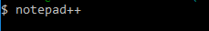

Now, notepad++ will open from Git bash shell

- To create an alias command for notepad++.exe, execute

It will open notepad++ from bash shell, and create a user profile by adding the line in notepad++

- To configure the editor, execute the command

- To verify if notepad++ is the default editor, execute the command
Here ‘-e’ option implies editor

It will show the entire global configuration as shown below,
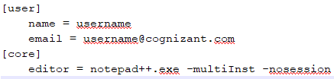

Step 3: Add a file to source code repository

- Open Git bash shell and create a new project “GitDemo” by executing the command

- Git bash initializes the “GitDemo” repository. To verify, execute the command
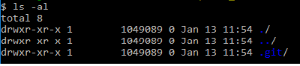
It will display all the hidden files in the Git “working directory”.

- To create a file “welcome.txt” and add content to the file, execute the command

- To verify if the file “welcome.txt” is created, execute
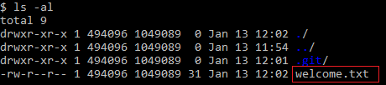

- To verify the content, execute the command

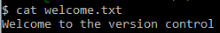

- Check the status by executing
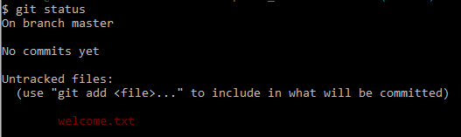

Now the file “welcome.txt” is available in Git “working directory”

- To make the file to be tracked by Git repository, execute the command

- To add multi line comments, we are opening default editor to comment. Execute the command

Notepad++ editor will open and to add multi-line comment with default editor

- To check if local and “Working Directory” git repository are same, execute git status

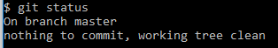

welcome.txt is added to the local repository.

- Signup with GitLab and create a remote repository “GitDemo”
- To pull the remote repository, execute

git pull origin master

- To push the local to remote repository, execute

git push origin master

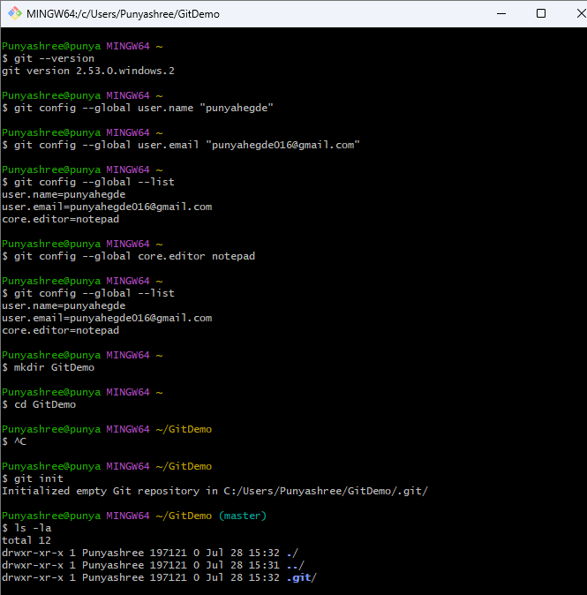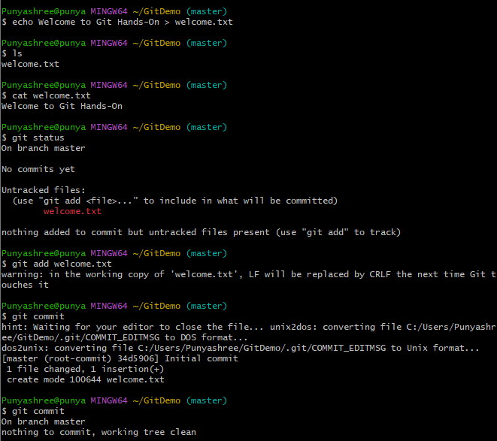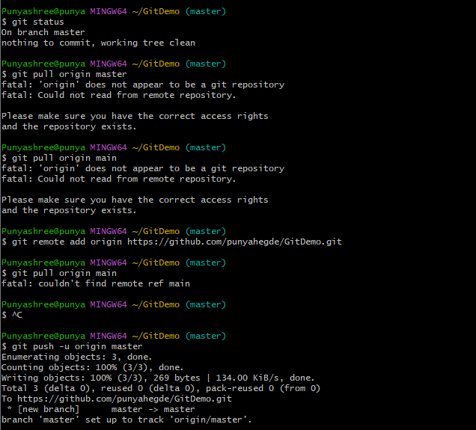

Objectives

- Explain git ignore
- Explain how to ignore unwanted files using git ignore

In this hands-on lab, you will learn how to:
- Implement git ignore command to ignore unwanted files and folders

Prerequisites

The following are the pre-requisites to complete this hands-on lab:
- Setting up Git environment
- Integrate notepad++ as a default editor
- A Git repository in the local system and a remote repository in GitLab
Notes*:

Please follow the below steps for creating a free account in GitHub.
Do not use cognizant credentials to login to GitHub.

Estimated time to complete this lab: 20 minutes.
Create a “.log” file and a log folder in the working directory of Git. Update the .gitignore file in such a way that on committing, these files (.log extensions and log folders) are ignored.
Verify if the git status reflects the same about working directory, local repository and git repository.

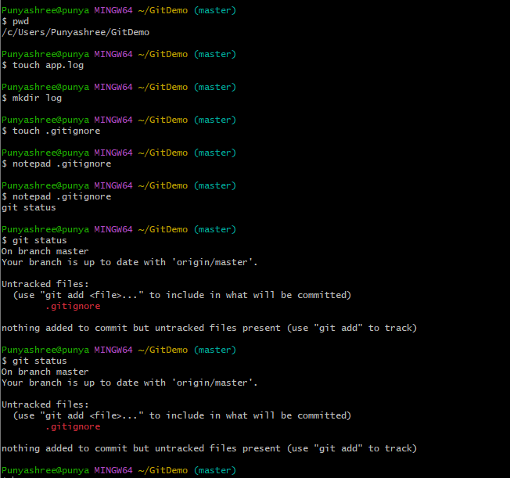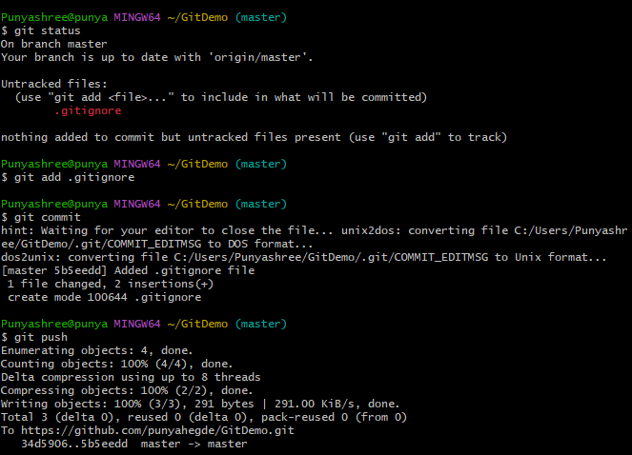

Objectives

- Explain branching and merging
- Explain about creating a branch request in GitLab
- Explain about creating a merge request in GitLab

In this hands-on lab, you will learn how to:
- Construct a branch, do some changes in the branch, and merge it with master (or trunk)

Prerequisites

The following are the pre-requisites to complete this hands-on lab:
- Setting up Git environment with P4Merge tool for Windows

Notes*:
Please follow the below steps for creating a free account in GitHub.
Do not use cognizant credentials to login to GitHub.

Estimated time to complete this lab: 30 minutes.
Please follow the instruction to complete the hands-on. Each instruction expects a command for the Git Bash.

Branching:
- Create a new branch “GitNewBranch”.
- List all the local and remote branches available in the current trunk. Observe the “*” mark which denote the current pointing branch.
- Switch to the newly created branch. Add some files to it with some contents.
- Commit the changes to the branch.
- Check the status with “git status” command.

Merging:
- Switch to the master
- List out all the differences between trunk and branch. These provide the differences in command line interface.
- List out all the visual differences between master and branch using P4Merge tool.
- Merge the source branch to the trunk.
- Observe the logging after merging using “git log –oneline –graph –decorate”
- Delete the branch after merging with the trunk and observe the git status.

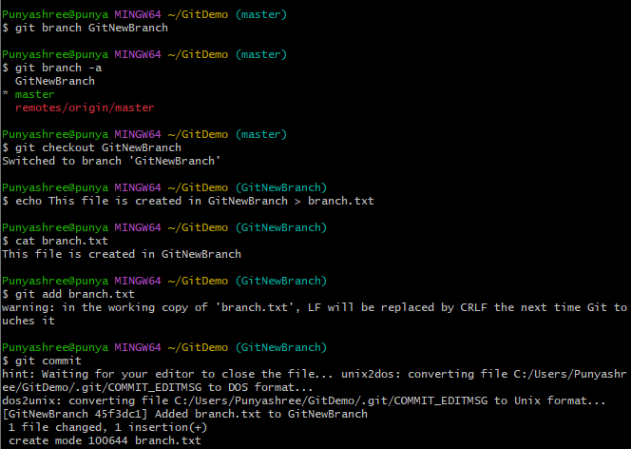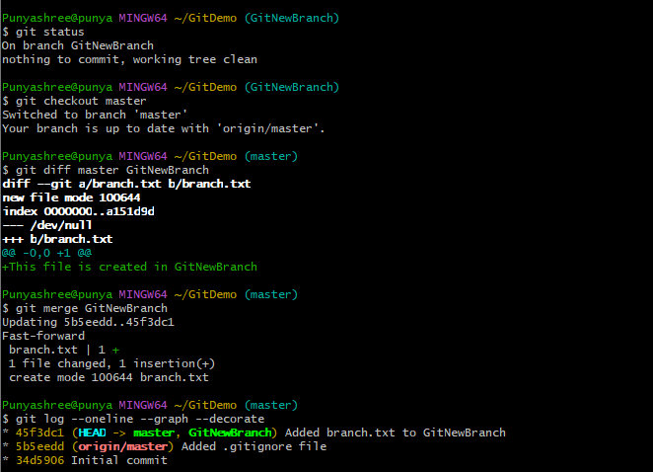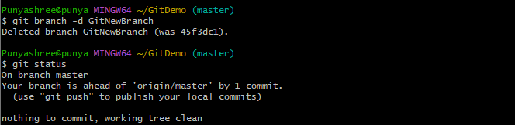

Objectives

- Explain how to resolve the conflict during merge.

In this hands-on lab, you will learn how to:
- Implement conflict resolution when multiple users are updating the trunk (or master) in such a way that it results into a conflict with the branch’s modification.

Prerequisites

The following are the pre-requisites to complete this hands-on lab:
- Hands-on ID: “Git-T03-HOL_001”

Notes*:
Please follow the below steps for creating a free account in GitHub.
Do not use cognizant credentials to login to GitHub.

Estimated time to complete this lab: 30 minutes.
Please follow the instructions to complete the hands-on. Each instruction expect a command for the Git Bash.
- Verify if master is in clean state.
- Create a branch “GitWork”. Add a file “hello.xml”.
- Update the content of “hello.xml” and observe the status
- Commit the changes to reflect in the branch
- Switch to master.
- Add a file “hello.xml” to the master and add some different content than previous.
- Commit the changes to the master
- Observe the log by executing “git log –oneline –graph –decorate –all”
- Check the differences with Git diff tool
- For better visualization, use P4Merge tool to list out all the differences between master and branch
- Merge the bran to the master
- Observe the git mark up.
- Use 3-way merge tool to resolve the conflict
- Commit the changes to the master, once done with conflict
- Observe the git status and add backup file to the .gitignore file.
- Commit the changes to the .gitignore
- List out all the available branches
- Delete the branch, which merge to master.
- Observe the log by executing “git log –oneline –graph –decorate”

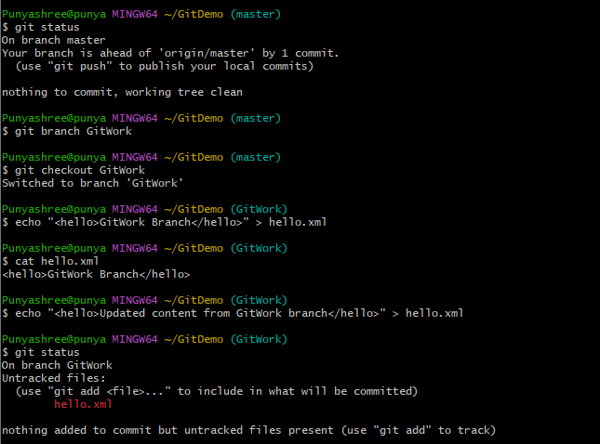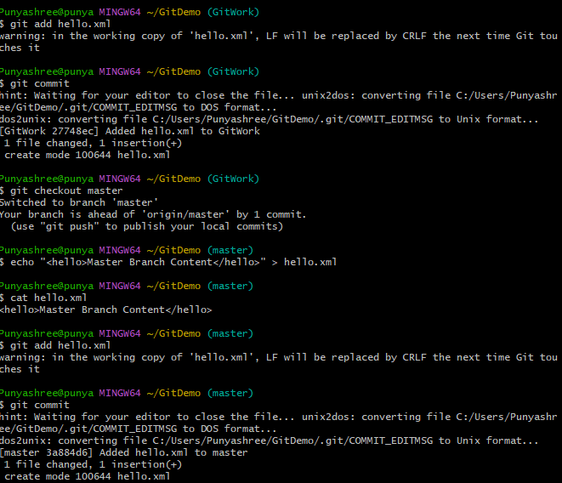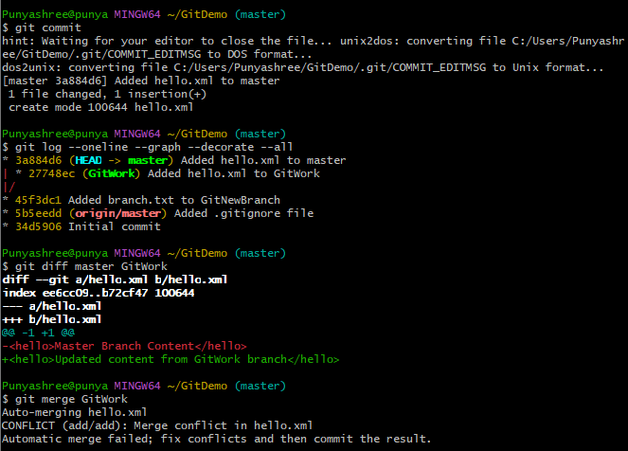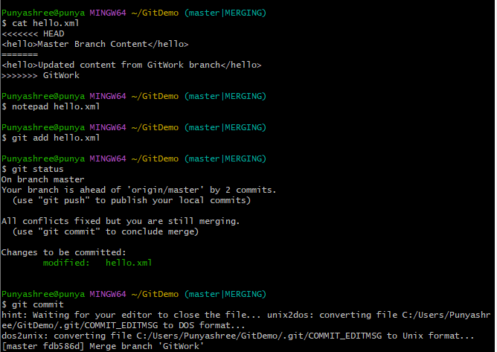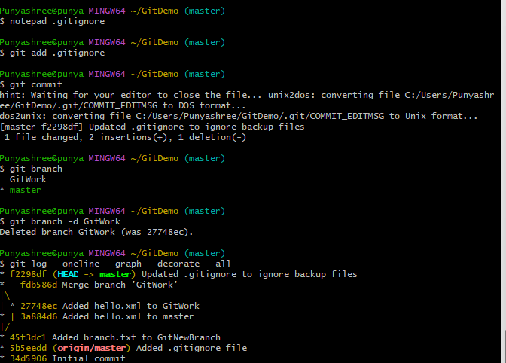

Objectives

- Explain how to clean up and push back to remote Git

In this hands-on lab, you will learn how to:
- Execute steps involving clean up and push back to remote Git.

Prerequisites

The following are the pre-requisites to complete this hands-on lab:
- Hands-on ID: “Git-T03-HOL_002”

Notes*:
Please follow the below steps for creating a free account in GitHub.
Do not use cognizant credentials to login to GitHub.

Estimated time to complete this lab: 10 minutes.
Please follow the instructions to complete the hands-on. Each instruction expects a command for the Git Bash.
- Verify if master is in clean state.
- List out all the available branches.
- Pull the remote git repository to the master
- Push the changes, which are pending from “Git-T03-HOL_002” to the remote repository.
- Observe if the changes are reflected in the remote repository.
